Dr. Ogra has continued to remain active in the laboratory as well as the clinical programs in Infectious Diseases. He returned to State University of New York and the Children’s Hospital of Buffalo in early 2000 as Professor of Pediatrics in the division of Infectious diseases in the department of Pediatrics. During his investigative career, he has trained over 75 post-doctoral fellows and PhD students in Microbiology and Immunology. During his academic career, Dr Ogra has been involved in the training of over 1000 Pediatric residents both in New York and in Texas.

Dr Ogra has been elected to membership of the Association of American Physicians, The Royal Society - Medicine and the American Society for Clinical Investigation and over 20 other scientific societies. He received the E. Mead Johnson Award from the American Academy of Pediatrics and the Stockton Kimball Award from the State University of New York for outstanding scientific contributions in pediatrics, and Kalhana Award from Kashmir cultural and Scientific society. In April 2006, he served as the Scholar - in - residence at the International vaccine Institute in Seoul, Korea.

Dr Ogra has served on several advisory panels at the World Health Organization, Study Sections of the National Institutes of Health, Advisory Boards of the Laboratory for Clinical Investigation - NIAID, National Institute of Environmental Health Science - NIH, US Armed Forces Research and Development Command, Maternal and Child Health Research Committee at NICHHD, and the advisory committees of several international congresses, FDA Committee on Vaccines and WHO Steering Committee on Measles and Acute Respiratory Diseases. He has served on the editorial boards of several scientific journals. He has also served as the Chairman of the Board, International Pediatric Research Foundation, Inc., which is responsible for publication of "Pediatric Research" journal.

Personal Background
Born in Kashmir, India. Early education in Kashmir. Attained medical degree in 1961 from the Christian Medical College, Ludhiana, and Punjab, India. Subsequent medical training in Pediatrics, Infectious Diseases, Clinical Virology and Immunology at the upstate Medical center - Binghamton General Hospital, University of Chicago-Bob's Roberts Children's Hospital (with the late Dr. Albert Dorfman), New York University-Bellevue Medical Center (with the Late Dr. Saul Krugman), and at the State University of New York (with Dr. David Karzon.).

Ministarstvo znanosti, obrazovanja i športa
Hrvatski zavod za javno zdravstvo
Medicinski fakultet Sveučilišta u Zagrebu

Pozivaju Vas na predavanje

Pearay L. Ogra, M.D
John Sealy Distinguished Chair Professor and Chairman (Emeritus), Dept. of Pediatrics at University of Texas Medical Branch at Galveston, TX and Professor of Pediatrics at Children's Hospital and State University of New York at Buffalo, 219 Bryant Street Buffalo, NY 14222, USA.

"Mucosal Immunity from Cradle to Coffin: Implications in vaccine induced immunity and ageing"

Pokroviteljstvo:
Croatian Ministry of Science grant (No. 005-0053443-3447/GMG),
Microbiology Services, Croatian National Institute of Public Health,
Department of Microbiology, Medical School, University of Zagreb (doctoral study-GP 027)
(Prof. G.Mlinaric-Galinovic, M.D.
CNIPH, Rockefellerova 12, 10 000 Zagreb, Croatia
Fax: 385 (1) 4683-017, phone: 385 (1) 4863-210,
E-mail: gordana.galinovic @ hzjz.hr)

Zagreb, 07. srpnja 2011.

Dvorana „A“ u 13.00 sati

Škola narodnog zdravlja „A. Štampar
Rockefellerova 4, Zagreb
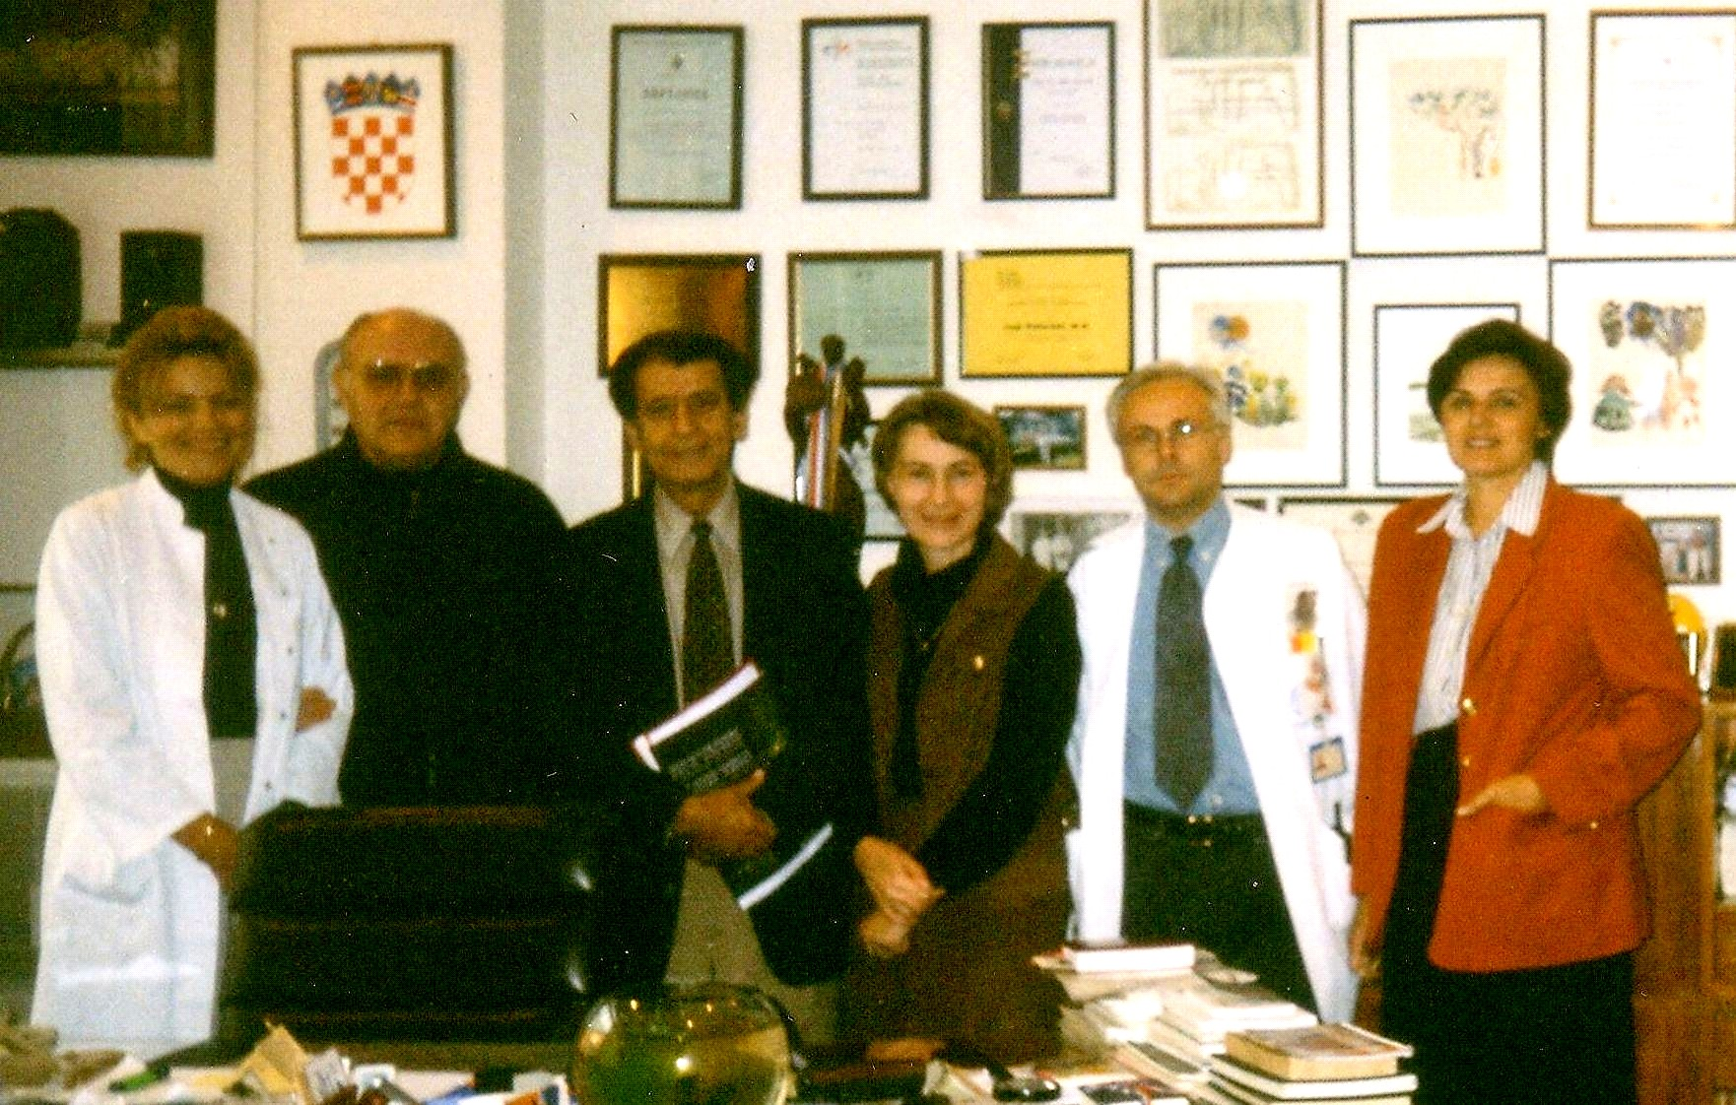
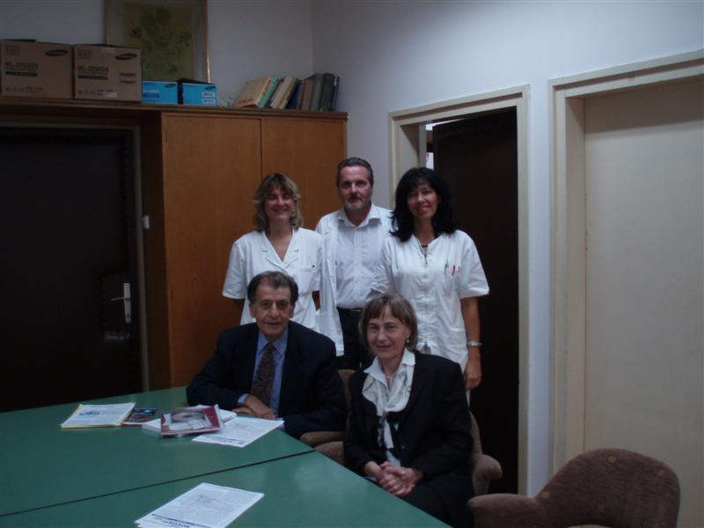
Dr. Ogra’s visit to the Univ. Children’s Hospital Zagreb - 1999.

Dr. Ogra’s visit to the Croatian National Institute of Public
Health - 2006.

Dr. Pearay L. Ogra

John Sealy Distinguished Chair Professor and Chairman (Emeritus), Dept. of Pediatrics at University of Texas Medical Branch at Galveston, TX and Professor of Pediatrics at Children's Hospital and State University of New York at Buffalo, 219 Bryant Street Buffalo, NY 14222, USA.

BIOGRAPHICAL SKETCH

Dr. Ogra’s career in academic medicine began in the early 1960’s. His research has focused on natural and experimentally induced host-pathogen interactions, studies on vaccine efficacy and vaccine development, and cellular and molecular aspects of mucosal immunity. His major scientific contributions began in 1968 with the first functional characterization of secretory IgA and "alimentary" mucosal immunity to poliovirus. In subsequent series of investigations, he defined the role of secretory IgA and cellular mucosal immune response to such human infections as rubella, mumps, hepatitis B and enteroviruses. During the mid-seventies, his laboratory provided extensive immunologic characterization of human milk, its role in maternal-neonatal interactions and childhood infections, and the association of mammary glands with other mucosal surfaces of the common mucosal immune system.
Since the early eighties, other investigations from his laboratory and his other colleagues have identified components of host-pathogen interactions underlying the pathogenesis of respiratory and enteric viral infections, notably in bronchiolitis due to respiratory syncytial virus (RSV) and gastroenteritis due to rotavirus in man. These include demonstration, for the first time, of RSV specific IgE antibody in the respiratory mucosa and its role in viral induced reactive airway disease. Other innovative experiments from his colleagues have provided identification of rotavirus specific receptor-binding sites in villous enterocytes in early infancy, and the role of bifidobacteria in modulating rotavirus-mucosal cell interactions. Currently, vaccine development, especially via the mucosal route is an area of intense scientific effort throughout the world and the observations from his laboratory on viral specific secretory IgA have contributed significantly to the current concepts of secretory immunity and the clinical exploration of several mucosal vaccines. These investigations have resulted to date in over 400 original papers and review articles, and 16 full-length books and monographs, including the first comprehensive textbook of “Mucosal Immunology”.

In 1991, Dr. Ogra was appointed the John Sealy Distinguished Chair Professor and Professor - Chairman, Department of Pediatrics and Pediatrician-in-Chief, at the Children's Hospital, and Professor of Microbiology and Immunology at the University of Texas Medical Branch in Galveston, Texas. He retired from this position in 2001. During his tenure as the chairman, the department underwent immense growth in several academic areas. These included increase in the Federal research funding in the department by about ten-fold. A new research program funded by NICHD established one of the first Child Health Research Centers in the Department of Pediatrics at UTMB and establishment of a full service Children’s Hospital in Galveston. At the time of his retirement from the chair, the Department had four endowed professorships, and an active NIH funded program in child health.

