High-Resolution Ultrasound Imaging

Vevo 2100 Imaging Platform
Hands-on Workshop

June 9th and 10th 2015
Biology Hall and Department of Medical Biology
School of Medicine University of Zagreb

REGISTRATION FORM
First name
Last name
Title
Function
Department
Institution
e-mail
Phone (optional)

By sending the Registration form at nino.sincic@mef.hr
You are confirming your attendance at the hands-on workshop

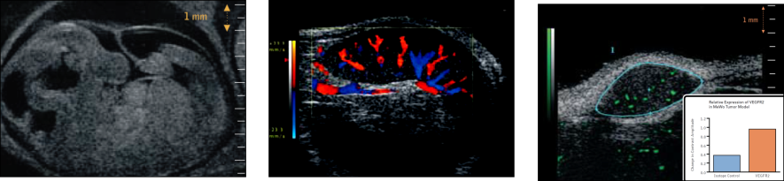

TRY IT FOR YOURSELF
AND
“SEE THINGS YOU HAVEN’T SEEN BEFORE”

In organisation of:

BioTech-Europe

Department of Medical Biology
School of Medicine University of Zagreb

RU for Biomedical investigation on Reproduction and Development
Centre of Excellence for Reproductive and Regenerative Medicine (CERR)

